PR 291 project
Snake game in C language
Guru Nanank Institute of Technology

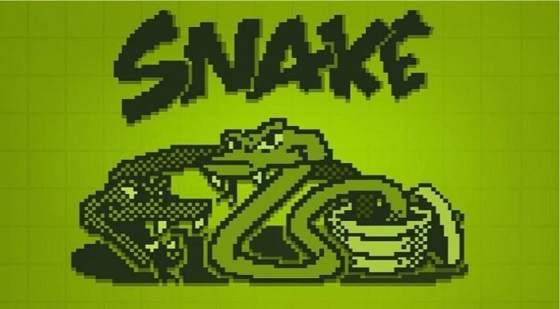
Created by:
- Tridha Das (138)
- Subham Bose (139)
- Trishita Mukherjee (140)
- Soumyadeep Dey (141)
- Somsubhra kar (142)
- Sayan Kumar Ghosh (143)
[ Project group C ]
[1st year,2nd semester (Batch of 2020-24)]

ACKNOWLEDGEMENT

Presentation, inspiration and motivation have always played a key role in the success of any venture.
We express our sincere thanks to Prof (Dr.) Santanu Kr Sen, Principal, GNIT.
We pay our deep sense of gratitude to Dr. Rupak Chakraborty and our guide whose valuable guidance and kind supervision given to us throughout the course which shaped the present work as it shows, and to encourage us to the highest peak and to provide us the opportunity to prepare the project.
Last but not the least, our parents are also an important inspiration for us. So, with due regards, we express our gratitude to them.

Introduction
The project is called the "Snake Game" which is the classic game, where we can control the movements of a snake's head using some keys, and the target is to eat as many fruits as possible, it's an arcade game.so the aim is to get our personal highest score or to beat other people's high scores.
The challenge however is that the snake's head can neither hit the boundary walls not it's own tail.

We have made the game in C language using modular programming and creating several
functions, each responsible for a specific task. Like this it will be more maintainable
and readable, the bugs can also be fixed and spotted easily.

We have incorporated datastructures like 1 dimentional arrays and several concepts like
nested looping, rand() to randomize the spawning coordinate of the fruit, getch() to get
input from the user and based on that deciding the direction of the snakes head, and algorithms
to increase the length of the snake and store the new coordinates by shifting the older coordinates
in the array through swapping from left to right(explained in detail later).

After the game is over, one can press the 'y' key and it will show the score the person has scored.
We also tested the game vigorously and it's completely functional with no bugs.

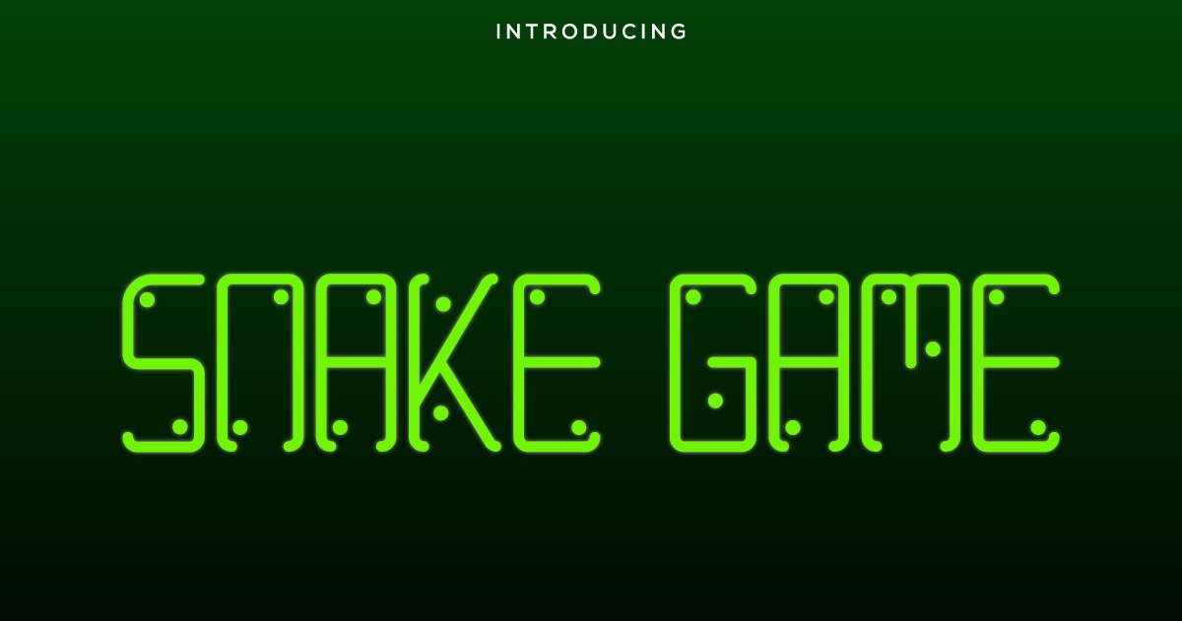

Flow diagrams
Ture
If gameover==1
Ture
Calling draw() , input() , logic()
1
We call setup()
start

Ture
Ch is equal ‘y’ or ‘Y’
Declaring ch
Print gameover and the score
Ch=get(ch)
end

False

False
end
kbhit
int main()
Start

start
Start
True

Switch(getch)
Initialize gameover =0
X=width/2, y= hight/2
Print the play-ground using nested loop inter loop as rows inner loop as column

For case ‘a’ flag=1
For case ’d’ flag = 2
For case ‘w’ flag =3
For case ‘s’ flag= 4
Case ‘x’ gameover = 1
And brake after every case
Randomly generate co-ordinates of fruit using rand()
Print symbols of snake head, fruit, Snake tail, Blank space accordingly to their respective conditions.

end
end
end

setup() draw() input()
Switch flag
If case 1; x--
If case 2; x++
If case 3; y--
If case 4; y++And for default just break and break for every case as well
Perform an algorithm to update the value in taily and tailx arrays
Start

If coordinate of snake head and fruit match, generate a new random values of fruity and fruitx and increment score by 10 and counttail by 1
Change gameover to 1 if conditional are (ki likheche bujhte prchina) like snake's head touches wall or its tail

end

logic()
Description of the Project

First of all we declare and initialize the global variables.
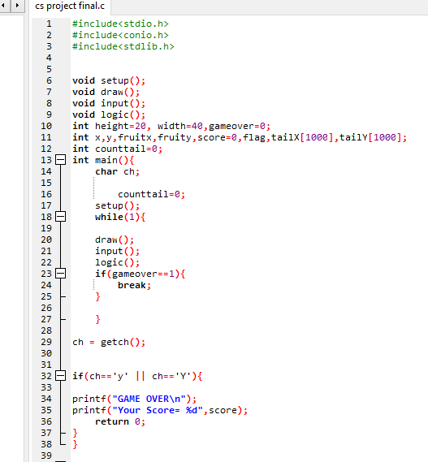
height - height of the boundary wall
width - width of the boundary wall
gameover - denotes if the game is going on or not.
x,y - coordinates of the snake's head
fruitx, fruity - coordinates of the fruit
score - total points the player has scored, 10 points for eating each fruit.
flag - represents the current direction of the snakes head.
The main function starts with declaring 'ch' variable, then we declare and initialize counttail to 0 as the starting length of the snakes tail is zero. Then we call the setup function once to initialize the variables to their initial values. Then we start a infinite loop as '1' as condition which will always stay true, in this while loop we call draw() then input() then logic() in this particular sequence. If at any point the value of 'gameover' variable becomes 1 we break the loop using the break statement. After that we take input ch using getch() and check if it is equal to either 'y' or 'Y' ,if this condition is true we will simply print "GAME OVER" and the score the player has scored.

int main(){
The main function starts with declaring 'ch' variable, then we declare and initialize counttail to 0 as the starting length of the snakes tail is zero. Then we call the setup function once to initialize the variables to their initial values. Then we start a infinite loop as '1' as condition which will always stay true, in this while loop we call draw() then input() then logic() in this particular sequence. If at any point the value of 'gameover' variable becomes 1 we break the loop using the break statement.After that we take input ch using getch() and check if it is equal to either 'y' or 'Y' ,if this condition is true we will simply print "GAME OVER" and the score the player has scored.

setup() -
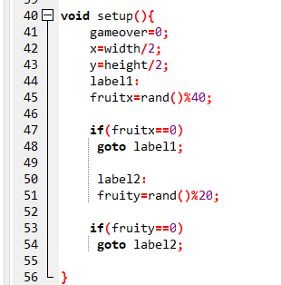
We initialize gameover variable as 0 as the game has just started, when the snake has hit the wall or it's own tail it will be changed to 1.The initial coordinates of the snake are kept width/2 and height/2 for x and y repectively as we want to spawn it around the center.Now we initialize the coordinates of the fruit. We want the coordinates of the fruit to be random and we also want it to lie in the range [1,height or width -1]
so that it doesn't spawn outside or at the same coordinates of the boundary wall.
That's why for fruitx coordinate we do rand()%39 as the width of the boundary is
40(from 0 to 39).rand()%39 means the remainder can only lie in the range [0,38].
However we don't want it to spawn at 0, so if it randomly comes 0, we use 'goto' statement and find another random value of fruitx and this happens until we find something non zero.
draw() -
We first initialize i and j to use them later in the nested for loop.
We also clear the console so the previous game position(position of the snake, length of the snake,etc)
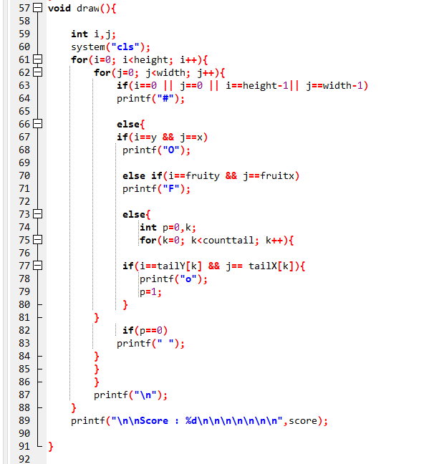
get's erased and we can print the current situation in the game.We do this using - system("cls");in line 60 Now we have to print the entire play area which is a rectangle. For this we use a nested loop in which the the outer loop is responsible for the number of rows and the inner row is responsible for the number of columns.
The outer loop runs from i=0 ,i++ as long as i<height, and the inner loop runs from j=0 ,j++ aslong as j<width
Inside the nested loop we will give several conditions, according to which
the snake's head, snake's tail, fruit, boundary wall and empty spaces will be printed.

1) We will print the boundary wall if any of the following conditions are satisfied
i) i == 0 , for the top boundary wall
ii) j == 0, for the left most boundary wall
iii) i == height - 1, for the bottom boundary wall
iv) j == width -1, for the right most boundary wall
2) Now in the else part
i) x and y are the coordinates of the snake's head so if i==y && j==x satisfies.
we should print the snakes head, which is represented as "O"
ii) fruitx and fruity are the coordinates of the fruit so if i==fruity && j==fruitx
satisfies we can print the fruit which is represented as "F"
iii) For the snake's tail we will loop through the arrays taily and tailx using a
single loop from k=0, k++ as long as k<counttail
and if we find that i and j are matching with any of the coordinates in the array using
if(i==tailY[k] && j== tailX[k]){
printf("o");
p = 1;
}
in line number 77 to 80, we will print the snakes tail which is represented as
"o"
3) Now if p==0 it means that we didn't find any coordinates in tailx or taily matching
so now we can print a blank space as shown in line 82 to 83
if(p==0)
printf(" ");
We also go to a newline after printing every row using "\n" escape sequence.
Now after printing the play area we also print the live score after some lines as
shown in line number 89 -
printf("\n\nScore : %d\n\n\n\n\n\n\n",score);

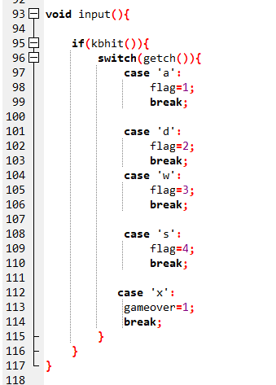
input()-
The use of the function is to determine the directions of the snake's head.
If (kbhit()){here creating a ‘If’ conditional statement and we are using the keyboard hit function [kbhit()]
to see if the user has pressed any key or not. If the user has pressed any key, then kbhit() returns true value and
go through if function.
Then,we used switchcase, in which we have to used getch(),to take input from user to move the snake up/down/left/right.
Then the code is,
case 'a':
flag=1;
break;
This means if value of flag is 1 then the user pressed a,
Similarly,
case 'd':
flag=2;
break;
This means if value of flag is 2 then the user pressed d,
Similarly,
case 'w':
flag=3;
break;
This means if value of flag is 3 then the user pressed w,

And also,
case 's':
flag=4;
break;
This means if value of flag is 4 then the user pressed s,
At last,
case 'x':
gameover=1;
break;
If user want to quit the game simply we need to press x, which triggers a gameover event.
What is meant by getch( ) and kbhit( ) ?
The getch( ) function basically stands for 'get character'. As one would understand from the
title, getch( ) gets a character from the user. The getch( ) function is usually used to hold the
output screen until the user presses on the keyboard, i.e.
the case of pressing any key to continue.
kbhit()- It is present in <conio.h> header file and is used to determine if a key has been pressed or not.It is different from scanf( ) or getch( ) as it continously checks for input from the user.
If a key has been pressed then it returns a returns non zero value(true value) otherwise zero value(false value).
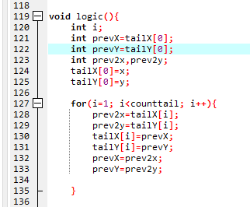
logic() - Here we need to implement an algorithm that will update the coordinates of the snakes tail.when ever a snake moves it's head which is (x,y) have new values and the first index of the tail array gets the coordinates of the previous head, now the first indexes in the tail array is updated with the previous 0th index, and so on, we are basically putting the new coordinate values in the head and shifting the arrays tailX and tailY to the right with 0th index having the old head coordinates. We achieve this by creating prevX,prevY and prev2x,prev2Y and using the algorithm from line number 120 to 134.

In this algorithm, we first of all store the initial values of prevX and prevY as tailX[0] and tailY[0], then we store x and y in tailX[0] and tailY[0] respectively.
Now we go iteratively from i=1 to 'counttail-1' and store coordinates of tailX[i] and tailY[i]
In prev2x and prev2y, then we store the values of prevX and prevY in tailX[i] and tailY[i], and atlast we store the values of prev2x and prev2y in prevX and prevY to prepare for the next iteration.

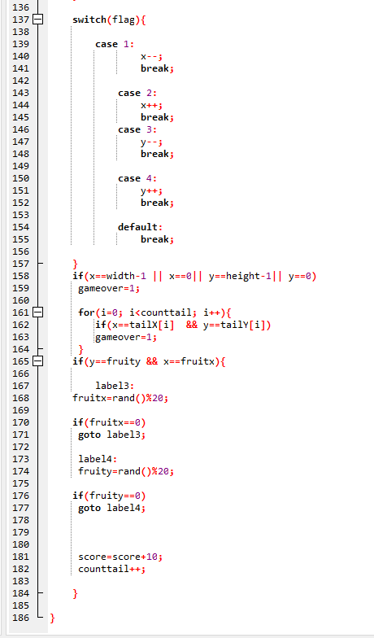
Now we also use switch case statements in which we take flag and if the value of flag is 1 it means
player has pressed 'a' which means player wants to move the snake towards left, so we will will
do 'x--', if flag is 2 it means player has pressed 'd' which means players wants the snake to move towards right and hence we do 'x++' similarly if flag is equal to 3 we do 'y--' and if flag is equal to 4 we do 'y++' which means downwards direction.

Now from line 158 to 164 we will specify the conditions to end the game or change the value of 'gameover' to 1 which will end the game loop in main.
The first condition is if the snake's head touches the boundary wall, which can be coded as -
if(x==width-1 || x==0|| y==height-1|| y==0)
gameover=1;

The second condition is if the snake's head has hit the snake's tail, for this we will iterate through the tail arrays and see if the coordinates of the head matches with any coordinate of the tail,
the code fo the same is -
for(i=0; i<counttail; i++){
if(x==tailX[i] && y==tailY[i])
gameover=1;
}

Now if we find a fruit, we generate new randomized coordinates of the fruit spawn ,similar to
what we did in set up.After generating new values of fruitx and fruity we will also increase the score by 10 points(as the player was successful at eating the fruit) and we will also increase the length of the snake by 1 as shown in line number 181 and 182.

Output:
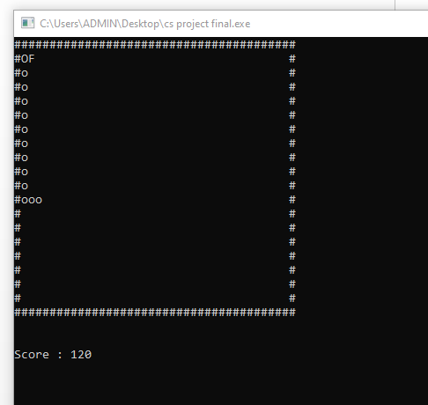
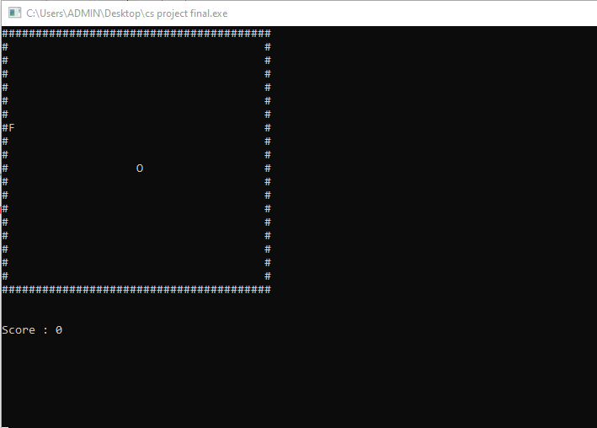

Start game (score 0) Game over (wall hit/body hit)

Conclusion

Through this project we have learnt to implement the C programming language concepts and data structures and create a full fledged game. We have also incorporated
several concepts like nested loops, functional programming, rand(),getch() and kbhit()
functions, goto statements, and several other things that we didn’t get a chance to implement and piece together to create a complete functional project.

Other than programming skills we also learned team work and cooporation, each of us contributed to the code and maintained the code on github.

We also tested the code vigorously so that we didn’t turn a blind eye to any corner case.
Hence due to teamwork, cooperation, and consistent efforts from everybody we managed to complete this project successfully.

